**Objective Questions**:

1. **What is the total no. of tables present in the data?**

There are 12 tables present (created) in the data.

1. **What is the total no. of attributes present in the data?**

Initially, the raw data had 20 attributes, but after cleaning and manipulating for the dashboard, it increased to 32.

Following Attributes were added:

* Cuisines(Imputed): To make up for the empty cells in the original Cuisines column. Each empty cell belonged to a restaurant based in America, so it was filled with American cuisine as it is the most common type of cuisine among the already present restaurants in America.
* Currency Symbol: To extract the symbol of the currency used in the restaurants.
* 4 Binary(0 &1) columns: Table Booking (1 or 0)  
   Online Delivery(1 or 0)  
   Delivering Now(1 or 0)  
   Switch (1 or 0)  
  This was done to keep the count of the number of restaurants providing these facilities error-free while using pivot tables.
* Average_Cost_with_Currency: Currency symbol and the average cost for 2 were merged in a single column.
* Currency_Multiplier_for_INR: Here, the multipliers were introduced to easily convert average cost for 2 in a single currency i.e Rs
* Average_Cost_In_Rupees: Average for 2 persons to dine in a restaurant is converted into Indian Rupees.
* 3 Date Columns: Datekey Opening(Year)  
   Datekey Opening(Month)  
   Datekey Opening(Day)

The inauguration dates were separated into Year, Month & Day respectively.

1. **How many categorical columns are there in the data?**

10

1. **The data consists of some inconsistent and missing values so ensure that the data used for further analysis is cleaned.**

There were no duplicate values present in the data but found 3 columns where missing cells were present, mainly:  
  
Longitude  
Latitude  
Cuisines

The location columns do not directly affect the type of analysis that was to be done, so the missing columns were not deleted as it would have impacted the other aspects.

In the cuisines column, all the missing values were from American restaurants and the most common cuisine found was American Cuisine, therefor all the empty cells were replaced by it.

1. **Using the LookUp functions, fill up the countries in the original data using the country code.**

Used VLOOKUP function to fill up the countries in the original data.  
  
FORMULA USED: =VLOOKUP('Raw Data'!$C2,'country description'!$A$1:$B$16,2,FALSE)

1. **Create a table to represent the number of restaurants opened in each country.**

Location: =Tables!A2

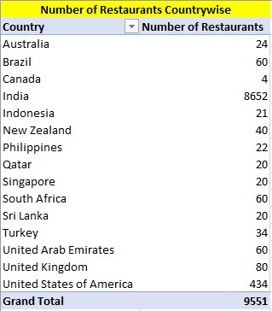

1. **Also, the management wants to look at the number of restaurants opened each year, so provide them with something here.**

Location: Tables!H2

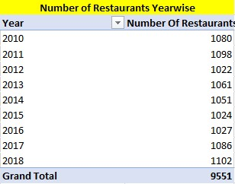

1. **What is the total number of restaurants in India in the price range of 4?**

388

FORMULA USED: =

COUNTIFS('Raw Data'!$C$1:$C$9552,"1",'Raw Data'!$W$1:$W$9552,"4")

1. **What is the average number of voters for the restaurants in each country according to the data?**

Location= Tables!H20

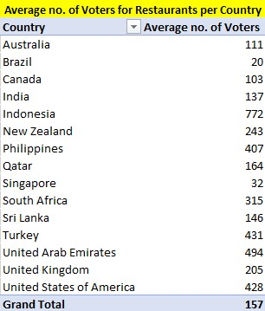

1. **Calculate the average rating for all the restaurants that have price_range < 4 and provide online delivery**.

3.273812

FORMULA USED=

=AVERAGEIFS('Raw Data'!$AC$1:$AC$9552,'Raw Data'!$W$1:$W$9552,"<4",'Raw Data'!$Q$1:$Q$9552,"Yes")

1. **Using Conditional formatting highlight the rows of restaurants that are located in the countries or cities that you’ve suggested to the management for opening new restaurants.**

Rows of Suggested countries (Indonesia, Philippines & Qatar) were highlighted.

1. **Create a new customized price column that consists of the abbreviation/symbol of the currency along with the Average_cost_for_two value**

The new column was created at ‘Z’ named Average_Cost_with_Currency.  
  
FORMULA USED: =CONCAT($N2,$Y2)  
  
Where, column N refers to Currency symbol & Y refers to average cost for two.

1. **How can you create an array formula in Excel or Google Sheets to count the number of restaurants listed that do not offer online delivery, are in the lowest price range, and have an average cost for two people less than or equal to 250 Indian Rupees?**

Answer=152

Formula Used:

=SUMPRODUCT(('Raw Data'!R:R=1)*('Raw Data'!W:W=1)*('Raw Data'!AB:AB<=250))

**Subjective Questions**:

1. **Suggest a few countries where the team can open newer restaurants with lesser competition. Which visualization/technique will you use here to justify the suggestions?**

Based on a comprehensive analysis, **Indonesia**, the **Philippines**, and **Qatar** are ideal for opening new restaurants. These countries **exhibit high average ratings** of existing restaurants, above the median, indicating strong customer satisfaction and a positive dining culture. They also have a **healthy number of restaurants**, again above the median, suggesting a thriving market with ample demand. Additionally, the average cost for two is above average, aligning with markets where **customers value quality and are willing to spend more** for premium dining experiences. This combination of high customer satisfaction, robust market demand, and higher spending capacity makes these countries strategically advantageous for new restaurant ventures, promising potential for successful market entry and growth.

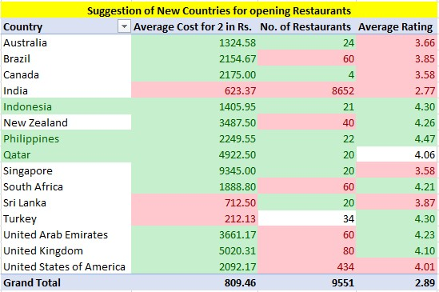

And to be precise:  
  
Countries with Average rating greater than or equal to the MEDIAN of rating i.e 4.06, number of restaurants less than the MEDIAN of the number of restaurants which is 34 and average cost for two above the overall AVEARGE i.e. 809.46 were chosen.  
  
Using conditional formatting, green fill was assigned to the favourable values and whichever country had all the green values in all 3 fields were chosen.  
In case of QATAR average rating was exactly 4.06, that’s why it has value in white but still considered as green.  
  
Formula Used for MEDIAN: =MEDIAN(Range)

1. **Come up with the names of States and cities in the suggested countries suitable for opening restaurants.**

In Indonesia, **Jakarta**; in Qatar, **Doha**; and in the Philippines, either **Pasig City or Pasay City** are ideal locations for new restaurants. These cities are renowned for dining and promise a good return on investment.  
  
The states/cities were chosen on the basis of the popularity of restaurants in the area and the higher traffic which comes with it.  
  
This selection process was done manually as the number of restaurants in each state is few, allowing for a thorough analysis of each location. Jakarta, with the highest number of restaurants in Indonesia, indicates significant customer traffic and strong demand for dining options. Doha, similarly, has a high concentration of restaurants with robust customer turnout, suggesting a healthy market for new entrants. In the Philippines, Pasig City and Pasay City were chosen because they boast the most restaurants within their state, reflecting high customer traffic and potential for good business. This manual analysis ensures that the selected cities not only have a substantial number of restaurants but also exhibit high customer engagement and satisfaction, making them suitable for opening new restaurants.

1. **According to the countries you suggested, what is the current quality regarding ratings for restaurants that are open there?**

The current average rating of the suggested countries is as follows:  
Indonesia- **4.30**  
Philippines- **4.47**

Qatar- **4.06**

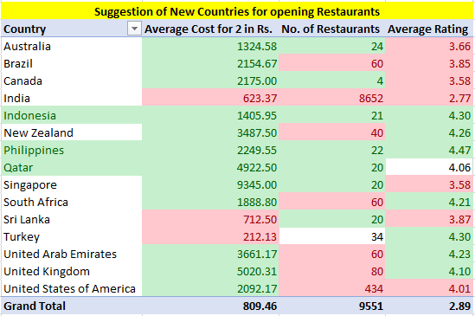

LOCATION: =Tables!P19  
  
Using Pivot table, taking the cleaned & manipulated data as reference, the average ratings of the suggested countries were evident.  
  
An average rating above 4 out of 5 indicates that customers are generally very satisfied with the restaurants in these locations. This suggests a positive market reception and a high standard of food quality and service. High ratings can indicate that people in these countries have a well-established culture of dining out, which bodes well for new restaurant ventures.

1. **Also, what is the current expenditure on food in the suggested countries, so we can keep our financial expenditure in control?**

The average cost for 2 persons in the suggested countries in Rupees is as follows:  
Indonesia- **₹1405.95**  
Philippines- **₹2249.55**

Qatar- **₹4922.50**LOCATION: =Tables!P19  
  
Using Pivot table, taking the cleaned & manipulated data as reference, the average cost for two in suggested countries were evident.

A higher average cost for dining out indicates that consumers in these countries have higher disposable incomes and are willing to spend more on dining experiences. This suggests a market with a substantial middle-to-upper-class population that values quality dining. The willingness to pay higher prices provides an opportunity for opening upscale or premium restaurants, which can generate higher margins and profits.

1. **Come up with the names of restaurants from the recommended states that are our biggest competitors and also those that are rated in the lower brackets, i.e. 1-2 or 2-3.**

Jakarta  
  
 Competitors- **Talaga Sampireun, Skye, Toodz House**

Low Rated- **None**

Doha

Competitors- **Zaffran Dining Experience, MRA Bakery Sweets & Restaurant**

Low Rated- **None**

Pasig City & Pasay City  
  
 Competitors- **Silantro Fil-Mex**

Low Rated- **None**

The selected potential competitors in these cities have been chosen based on three key criteria: higher average ratings (above 4), comparatively lower average cost for dining for two, and a high number of voters. These factors indicate that these restaurants deliver high-quality dining experiences at a reasonable cost, making them attractive to a broad customer base. The high number of voters signifies strong customer engagement and consistent traffic, suggesting these restaurants have successfully built a loyal customer base. By analysing such competitors, we can gain valuable insights into successful pricing strategies, popular menu offerings, and effective customer engagement tactics. Understanding their strengths allows us to benchmark our performance, identify areas for improvement, and develop competitive strategies that meet or exceed market expectations.

1. **Which cuisines should we focus on in the newer restaurants to get better feedback? Does the choice of cuisines affect the restaurant ratings?**

In Jakarta: **Sushi, Japanese & Western** cuisines seem to be the most loved cuisines.  
In Doha**: Indian** cuisine is the most preferred one.  
In Pasig City & Pasay City**: Filipino and Asian** cuisines are the go-to ones.   
  
And to back-up the choices with data: If we’d have filtered cuisines column much, it’d have shown over 1800 cuisines which included a lot of redundant data. And to convert text to column, it’d have again taken lot of unnecessary space with very little useful data.   
  
And as the suggested countries had only few restaurants, it was easy to manually choose the most popular cuisine that is consumed there.

And no, the choice of cuisines does not affect the ratings much. According to the data, all the restaurants are rated highly with very little variation, indicating that quality and economical cost must be the primary factors influencing ratings.  
  
Again manually observing the data extensively, there was nothing to differentiate between any of the cuisines, all the restaurants are highly rated having different cuisines.

1. **According to our current data, should we go for online delivery and table booking? Does that affect the customer’s ratings?**

Apart from India, there is very little data available to reflect a clear picture. In the case of India, despite being a top country for online food delivery, the average rating is low at 2.8. Therefore, online delivery and table booking have no correlation with customer ratings.

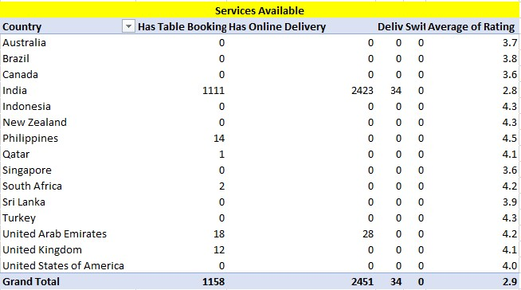

LOCATION: ='Pivots for Dashboard'!E3  
  
This conclusion was derived using a pivot table analysis of the available data. The pivot table allowed us to efficiently aggregate and examine the relationship between online delivery, table booking, and customer ratings across different regions. In India, the data clearly shows a high prevalence of online food delivery services, yet the average customer rating remains low at 2.8 out of 5. This indicates that the availability of online delivery and table booking services does not necessarily improve customer satisfaction. The pivot table analysis highlights that other factors, such as food quality, service, or delivery efficiency, might be impacting customer perceptions negatively. Consequently, based on the current data, investing in online delivery and table booking may not directly influence or enhance customer ratings. The decision should therefore consider other operational improvements to boost overall customer satisfaction.

1. **Should the team keep the rate of cuisines higher? Will that affect the feedback? According to our data are the rates of cuisines and ratings, correlated?**

It was very hard to analyze cuisines and link them to ratings, but what I found is that cuisines have very little to do with ratings. It was mainly restaurants and their locations. So, based on the location, we can keep the rates of certain cuisines higher.

The complexity of the data made it challenging to establish a direct correlation between the rates of cuisines and customer ratings. There were multiple cuisines listed for many restaurants, and Excel counted each cuisine as a separate entry, which complicated the analysis. Converting text to columns would have resulted in redundant data and unnecessary mess. Instead, by examining other related data, we concluded that higher income group countries tend to spend more on dining, and ratings may also depend on the type of cuisine provided in certain locations.

Using a pivot table analysis, it became evident that the location of the restaurant significantly impacts customer ratings. Higher-income areas show a propensity for higher spending and better ratings, suggesting that certain cuisines can command higher prices if positioned in suitable locations. Thus, while keeping the rates of certain cuisines higher in affluent areas could be viable, it is the restaurant's location that plays a more critical role in determining customer feedback.

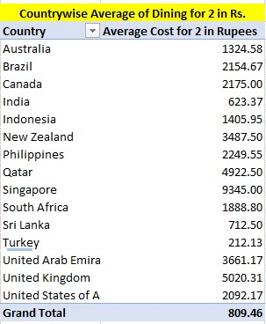

LOCATION: ='Pivots for Dashboard'!F25

1. **What is the distribution of the number of restaurants of different price ranges in all the countries?**

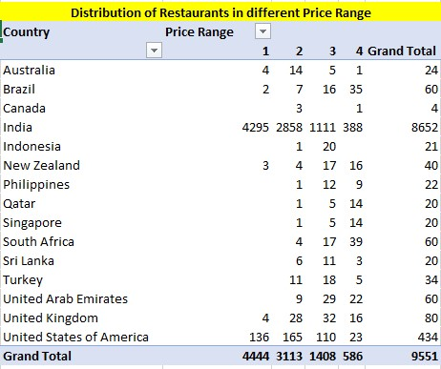

LOCATION='Pivots for Dashboard'!E47

The pivot table analysis shows that the distribution of restaurants varies significantly across countries and price ranges. India leads with the highest number of low-cost dining options, while countries like the USA and UAE have a more balanced distribution across all price ranges. This information can guide strategic decisions for restaurant openings, marketing, and pricing strategies, ensuring alignment with the dining market dynamics of each country.

1. **Explain your approach in brief for suggesting countries/cities in order to open new restaurants, if the objective and subjective questions would have been given to assist you.**

**Selection Criteria**

1. **Average Ratings of Existing Restaurants**:
   * The average ratings in these countries are above the median, indicating high customer satisfaction and a positive dining culture. High ratings suggest a receptive market where quality dining experiences are valued, which is crucial for establishing a successful restaurant business.
2. **Number of Restaurants**:
   * The number of restaurants in these countries is above the median. While a higher number of restaurants might initially suggest more competition, it also indicates a robust and thriving dining market. This factor, combined with high ratings, shows that these markets are not oversaturated and have a healthy demand for dining options.
3. **Average Cost for Two**:
   * The average cost for two is above average in these countries. Choosing countries with above-average dining costs aligns with targeting a market segment that values quality and is willing to spend more for a better dining experience. Higher costs can be indicative of higher disposable income and a preference for premium dining options, which can be advantageous for establishing a new restaurant aiming to provide high-quality offerings.

**Justification for High Average Cost for Two**

Selecting countries with an above-average cost for two ensures targeting markets where customers are accustomed to spending more on dining. This is beneficial for several reasons:

* **Higher Revenue Potential**: Restaurants in these markets can achieve higher revenue per customer, supporting sustainability and growth.
* **Quality Perception**: Higher prices are often associated with better quality, helping to position the new restaurant as a premium option.
* **Customer Demographics**: Markets with higher dining costs typically attract customers with higher disposable incomes, which can be a desirable target demographic for new, high-quality restaurants.

### Conclusion

In summary, Indonesia, the Philippines, and Qatar present attractive opportunities for opening new restaurants due to their high customer satisfaction, thriving restaurant markets, and higher average dining costs. These factors collectively suggest that these countries are well-positioned to support new high-quality dining establishments, offering the potential for significant market entry success. The visualizations will provide clear, data-driven insights to justify these recommendations and support strategic decision-making.